**Linux Driver Tool User Guide**



Huawei Technologies Co., Ltd.

All rights reserved

**1 Introduction**

This document instructs how to install data card driver tool in a Linux OS environment and how to configure the dialup connection for the data card.

The Linux OS referred to in this document is 2.6.18 kernel version or later, and this user guide use the FedoraCore 6.0 Linux distribution version.

**2 Intall the Linux Driver Tool**

2.1 Extract the package of the Linux Driver Tool for HUAWEI Data Card device on the Desktop. Then you will get the “driver” directory.

2.2 Open the Terminal tool and switch the user into super user (root).

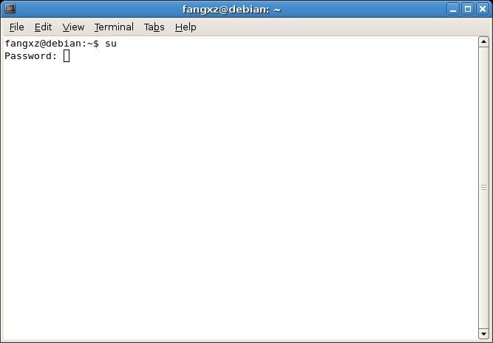

2.3 Enter the directory path of the Linux Driver Tool. For example, as the follows:

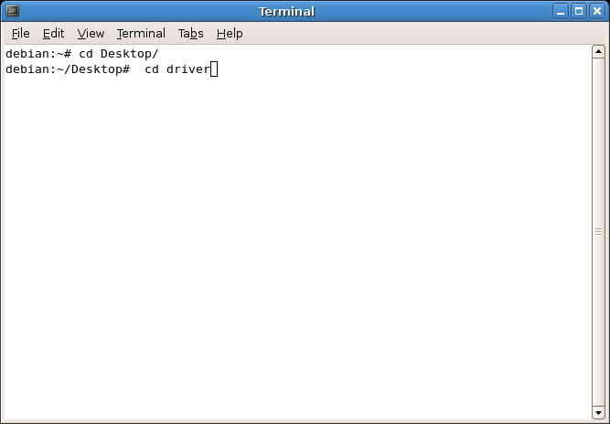

2.4 Type the command of “./install”, and make the path of the “driver” directory as the parameter, then click the “Enter” button to install the Linux Driver Tool.

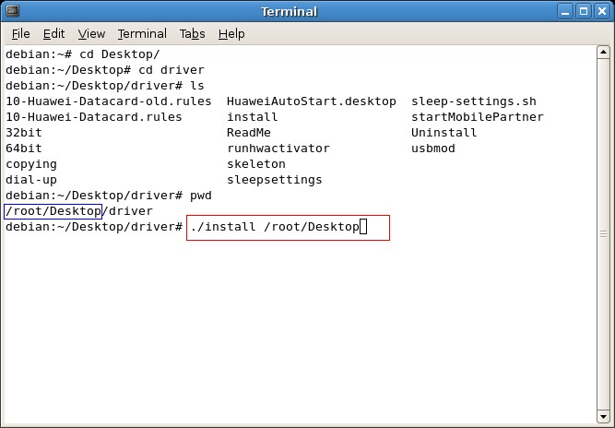

**3 Configuring Dialup Connection for Fedora**

3.1 Open “Network Configuration”

Application->System setting->Network

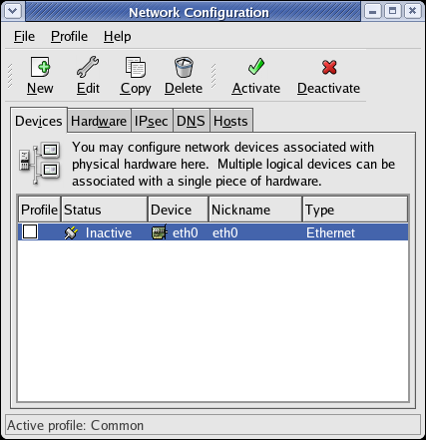

Figure 1 Open Network Configuration

3.2 Add new device and create a dialup connection

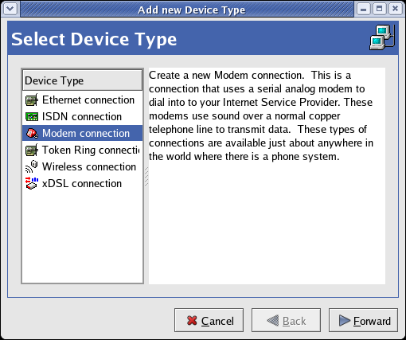

Figure 2 Select Device Type

Figure 3 Select modem device

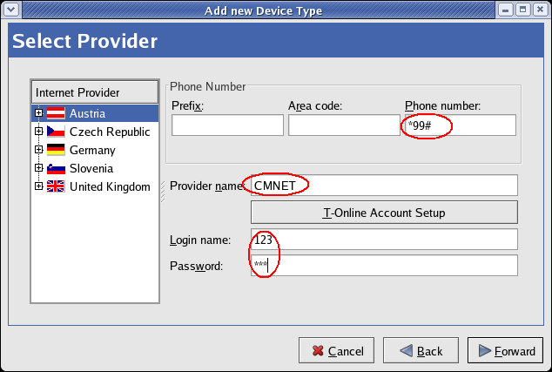

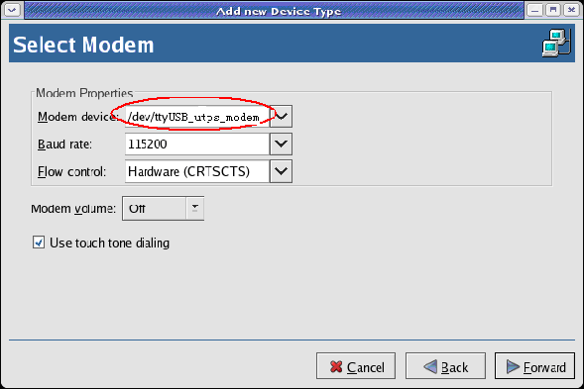

Figure 4 Select provider

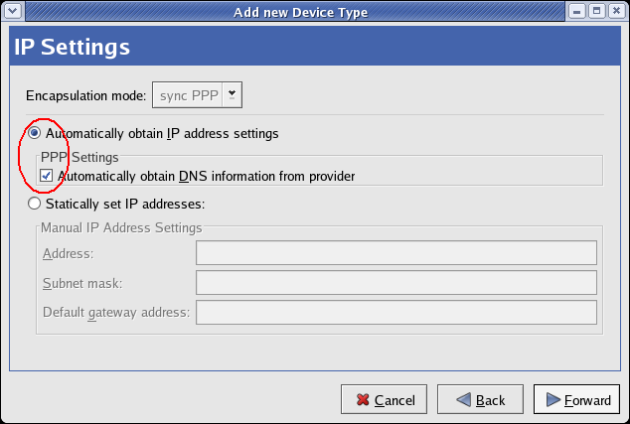

Figure5 IP address settings

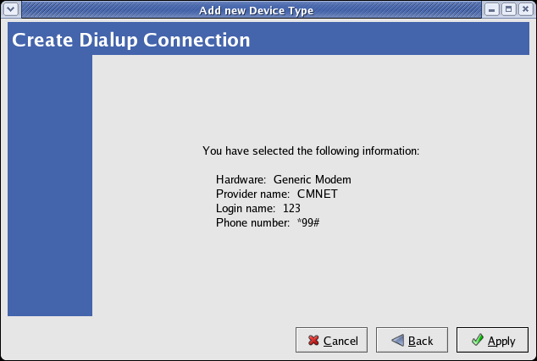

Figure6 Apply new connection

3.3 Save the configuration

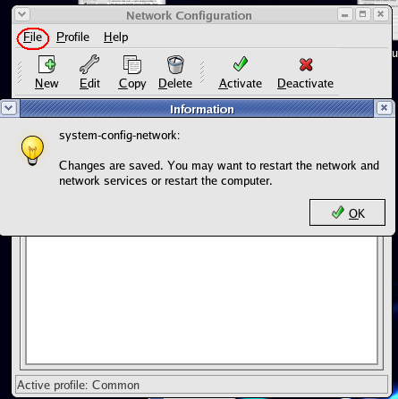

Figure 7 Save all configuration

3.4 Open the terminal tool and change the user into root

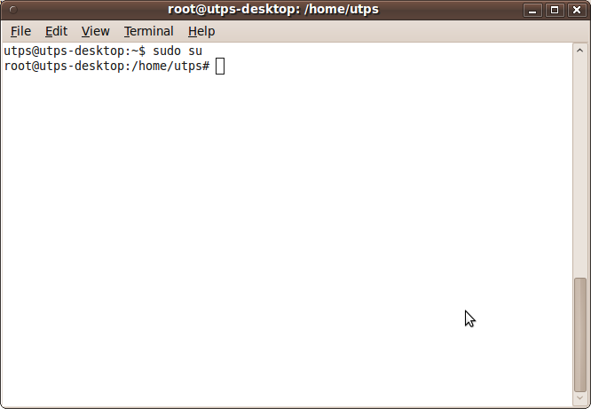

3.5 Enter the shell command as shown the image and then press “Enter” button.

Note: The string “uninor” is the apn name and it changes from one operator to the other. The following are the common apn names used for different operators in India (However, please check the APN Name from your operator):

|  |  |  |  |
| --- | --- | --- | --- |
| **Operator** | **APN Name** | **Username** | **Password** |
| Airtel | airtelgprs.com |  |  |
| Vodafone | www |  |  |
| Idea | internet |  |  |

|  |  |  |  |
| --- | --- | --- | --- |
| MTNL 3G(Default) | mtnl3g | mtnl | mtnl123 |
| MTNL 3G Prepaid | pps3g | mtnl | mtnl123 |
| MTNL Mumbai | gprsmtnlmum | mtnl | mtnl123 |
| MTNL Mumbai  Prepaid | gprsppsmum | mtnl | mtnl123 |
| MTNL Delhi | gprsmtnldel | mtnl | mtnl123 |
| MTNL Delhi Prepaid | gprsppsdel | mtnl | mtnl123 |
| Reliance RTL | smartnet |  |  |
| Reliance RCOM | rcomnet |  |  |
| Tata Docomo  (Default) | TATA.DOCOMO.INTERNET |  |  |
| Tata Docomo | tatadocomo3g |  |  |
| Aircel (Default) | aircelgprs |  |  |
| Aircel Online  Postpaid | aircelwebpost |  |  |
| Aircel Online Prepaid | aircelweb |  |  |
| Aircel Online TN Postpaid | aircelgprs.po |  |  |
| Aircel Online TN Prepaid | aircelgprs.pr |  |  |
| Videocon | vinternet.com |  |  |
| STEL | gprs.stel.in |  |  |
| Uninor | uninor |  |  |
| Loop | www |  |  |
| BSNL | bsnlnet |  |  |
| Etisalat | internet |  |  |

**Note:** *The blank values for username and password in the above table indicates that No username and password are needed.*

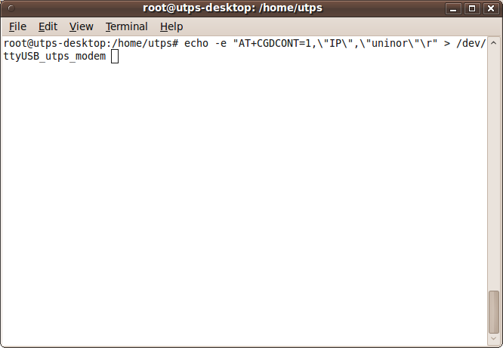

3.6 Click the ‘Activate’ button and the modem status will change to ‘Active’

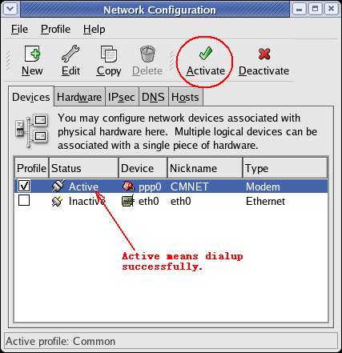

Figure 8 Activate the PPP connection

**4 Configuring Dialup Connection for Other Linux**

If the pppconfig has been installed on the current system, then can make the settings for dialing up as follows.

4.1 Open the Terminal tool and change the user into root.

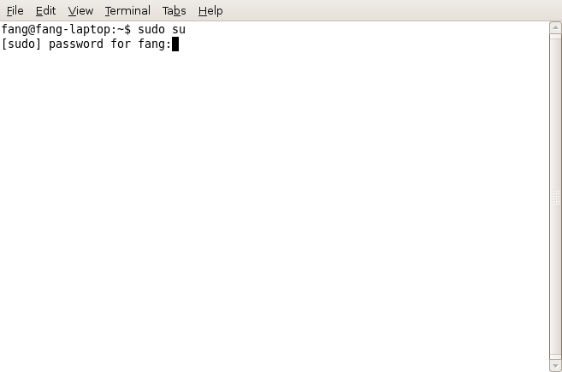

4.2 Enter the shell command “pppconfig”, and then click “Enter” button.

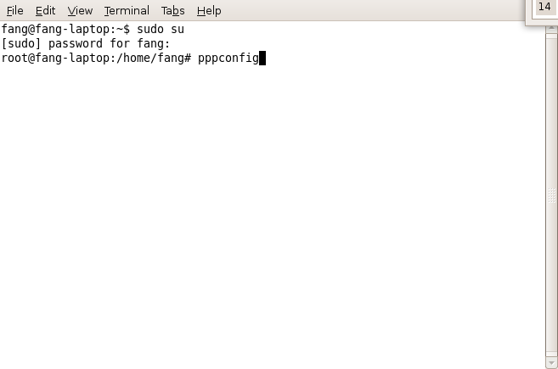

4.3 Select “Create Create a Connection” item on the Main Menu.

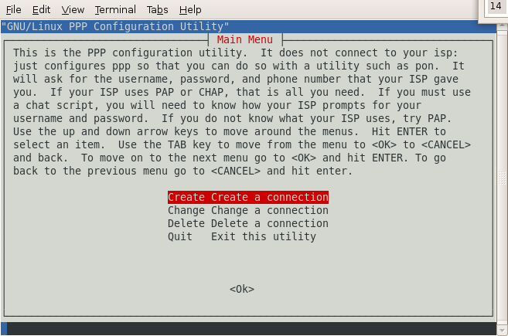

4.4 Enter the provider name of your ISP. Or you can make the default for it.

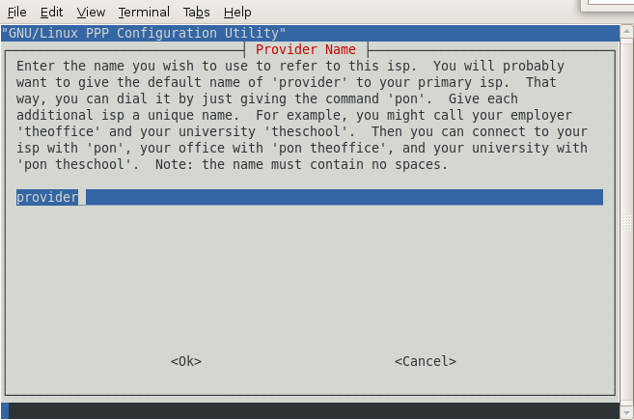

4.5 Select “Use dynamic DNS” item on the Configure Nameservers panel.

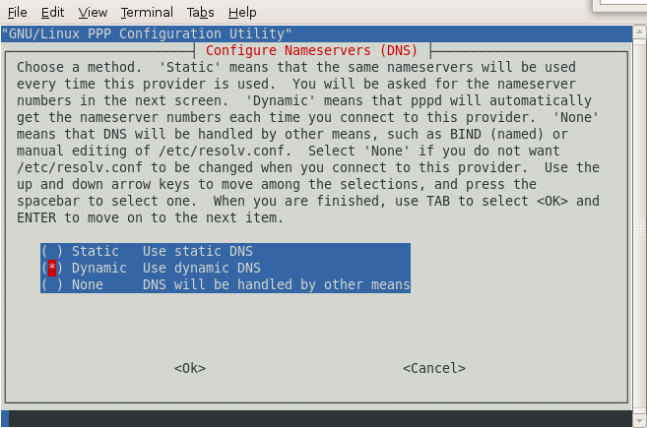

4.6 On the Authentication Method for provider panel, you can select PAP or

CHAP for your need. For default, it is PAP.

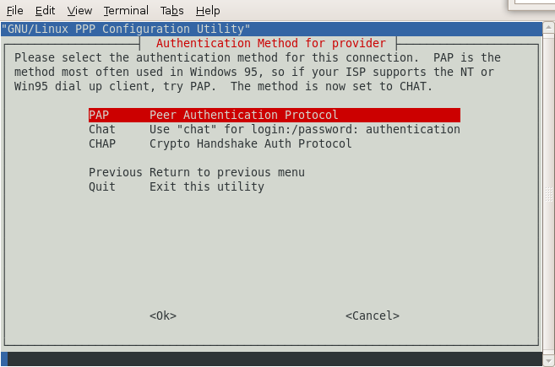

4.7 Enter the User Name given to you by your ISP. By default, you can enter the user name of you current Linux system for it.

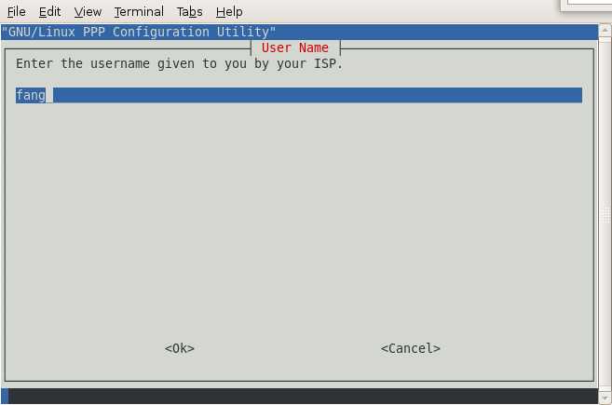

4.8 Enter the password given to you by your ISP. By default, you can enter the password of the current Linux system user name.

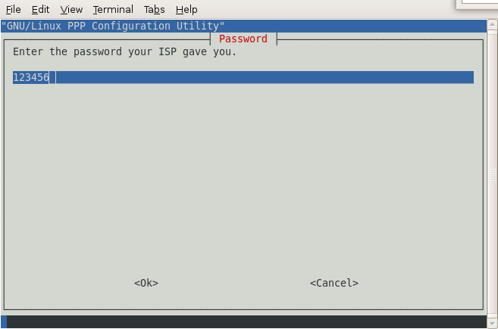

4.9 Make the default settings for the modem port speed.

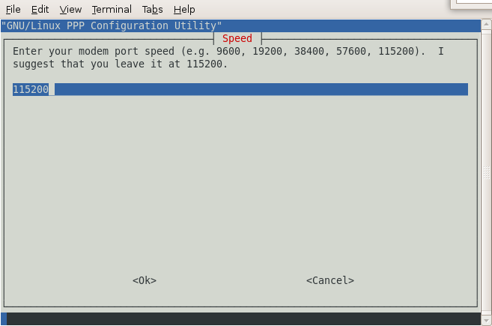

4.10 You can make the default settings for the method of dialing.

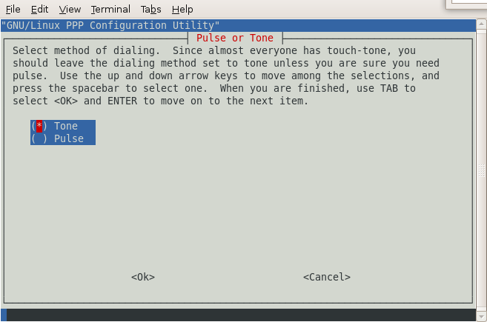

4.11 Enter the Phone Number given to you by your ISP.

In generally, it is *99# for WCDMA or GSM.

It is #777 for CDMA.

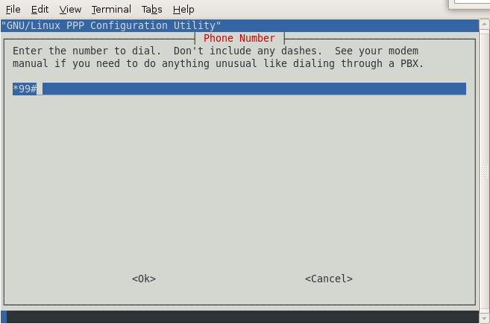

4.12 Select “Yes” on the Choose Modem Config Method panel.

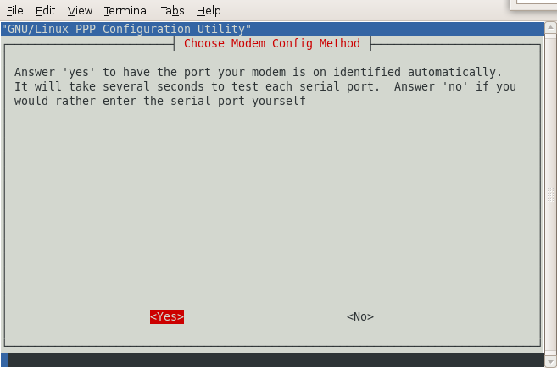

4.13 Select the item of “Manual Enter the port by hand”.

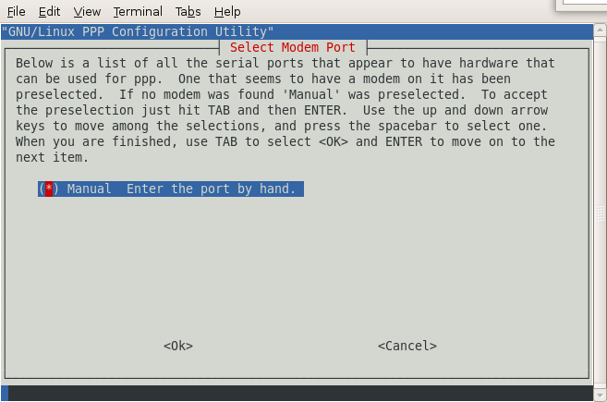

4.14 Enter the name of the modem port on the current Linux system. In general, the name of modem is /dev/ttyUSB_utps_modem.

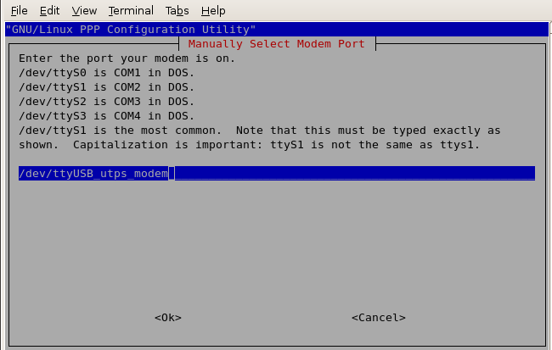

4.15 Check your settings on the “Properties of provider” panel. If it is all right, then select the item of “Finished Write files and return to main menu”

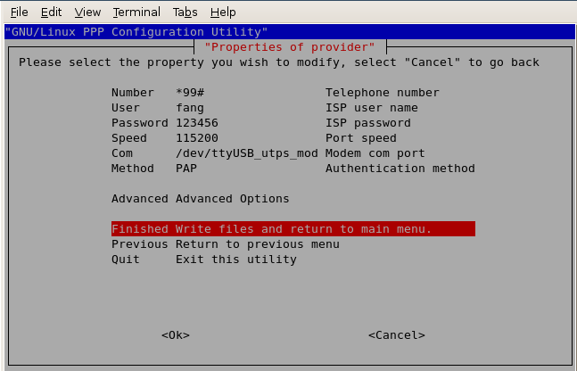

4.16 Click “OK” on the Finished panel.

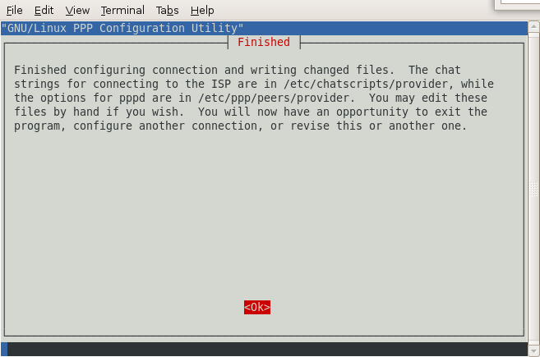

4.17 Then select the item of “Quit Exit this ultility” on the Main Menu panel.

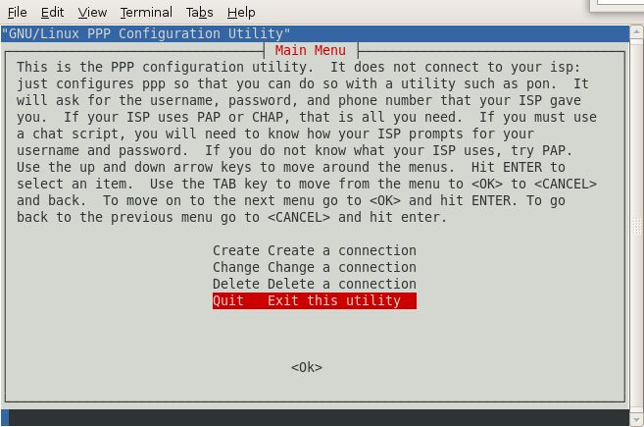

4.1 Enter the shell command as shown the image and then press “Enter” button.

Note: The string “uninor” is the apn name and it changes from one operator to the other. The following are the common apn names used for different operators in India (However, please check the APN Name from your operator):

|  |  |  |  |
| --- | --- | --- | --- |
| **Operator** | **APN Name** | **UserName** | **Password** |
| Airtel | airtelgprs.com |  |  |
| Vodafone | www |  |  |
| Idea | internet |  |  |
| MTNL 3G(Default) | mtnl3g | mtnl | mtnl123 |
| MTNL 3G Prepaid | pps3g | mtnl | mtnl123 |
| MTNL Mumbai | gprsmtnlmum | mtnl | mtnl123 |
| MTNL Mumbai  Prepaid | gprsppsmum | mtnl | mtnl123 |
| MTNL Delhi | gprsmtnldel | mtnl | mtnl123 |
| MTNL Delhi Prepaid | gprsppsdel | mtnl | mtnl123 |
| Reliance RTL | smartnet |  |  |
| Reliance RCOM | rcomnet |  |  |
| Tata Docomo  (Default) | TATA.DOCOMO.INTERNET |  |  |
| Tata Docomo | tatadocomo3g |  |  |
| Aircel (Default) | aircelgprs |  |  |
| Aircel Online | aircelwebpost |  |  |

|  |  |  |  |
| --- | --- | --- | --- |
| Postpaid |  |  |  |
| Aircel Online Prepaid | aircelweb |  |  |
| Aircel Online TN Postpaid | aircelgprs.po |  |  |
| Aircel Online TN Prepaid | aircelgprs.pr |  |  |
| Videocon | vinternet.com |  |  |
| STEL | gprs.stel.in |  |  |
| Uninor | uninor |  |  |
| Loop | www |  |  |
| BSNL | bsnlnet |  |  |
| Etisalat | internet |  |  |

**Note:** *The blank values for username and password in the above table indicates that No username and password are needed.*

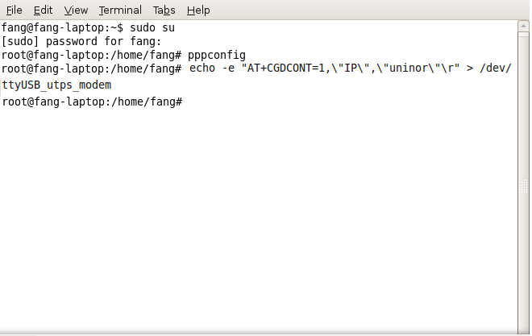

4.2 After you finished the dialing up settings for the data card modem, you can execute the command of “pon” on the terminal. And then the modem will dial up to connect with Network.

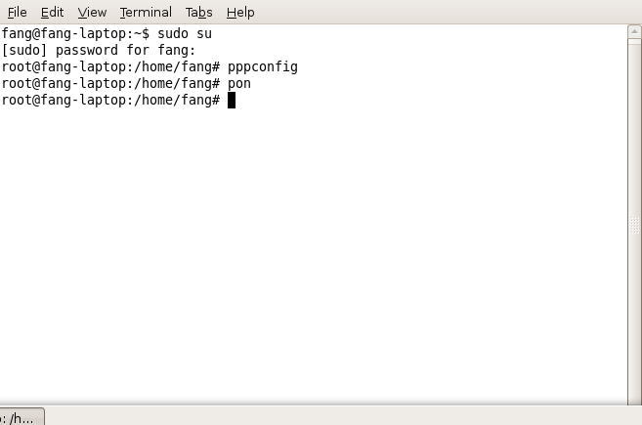

4.3 If you want to disconnect, you can execute the command of “poff” on the

Terminal, and then click “Enter”.

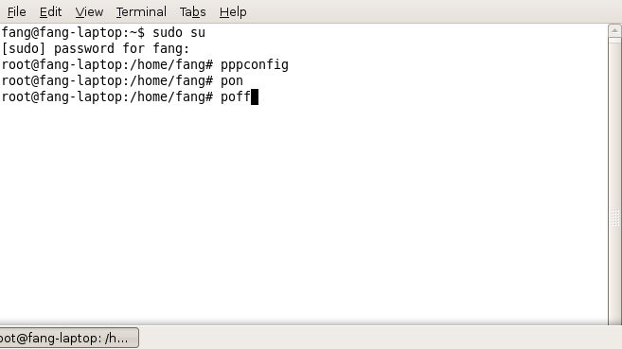

**5 FAQ**

**5.1 The problem of “”Failed to activate … with error 2” prompt while dialing up with the Network Tool build-in the Linux distributions.**

This error prompt means that the modem device can not be found. And the solution is to:

1) Open the Network Tool and check the hardware settings for the modem port are correct.

2) Open the Terminal tools, use "ls / dev / ttyUSB *" command to view the modem port whether exists in system or not. In generally, the modem port is often showed as "ttyUSB0".

3) If it does not exist, that means the name of modem port has been changed, due to some operations. For example, the system goes into Hibernate or Sleep while the modem is dailed up to connected with the network, then after the system waking up, the modem port name will be changed.

4) To solve this problem, you must re-plug the data card device on the system.

**5.2 The problem of “”Failed to activate … with error 6” prompt while dialing up with the Network Tool build-in the Linux distributions.**

This error prompt means that the modem script runs failed before the modem connecting with the network. And the solution is to:

1) Generally speaking, in such circumstances, the re-dial-up can solve the problem.

2) However, if the re-dial still failed, then that means the modem port might be locked by some other process. At that time, users can run the command of "tail -f /var/log/messages" on the Terminal tool, then dialing up again, and check the dialing output information on the Terminal

to find the process ID which locks the modem port. Then to kill this process to solve this problem.

3) Another method is to re-plug the data card, then it also can solve the problem.

**5.3 The modem port and PCUI port with Product ID 0x1003 is attached to airprime driver module in Ubuntu 8.04**

This is a system bug, it will cause data card devices can not communicate with the dashboard or other applications.

To solve this problem, please do as follows:

1) Unplug the data card device from Ubuntu 8.04

2) Unregister the airprime driver from USB bus:

rmmod -f airprime

3) Remove the airprime.ko module from Ubuntu 8.04 kernel:

rm /lib/modules/$(uname –r)/kernel/drivers/usb/serial/airprime.ko depmod -a

4) Plug the data card device into Ubuntu 8.04, then the problem can be solve.